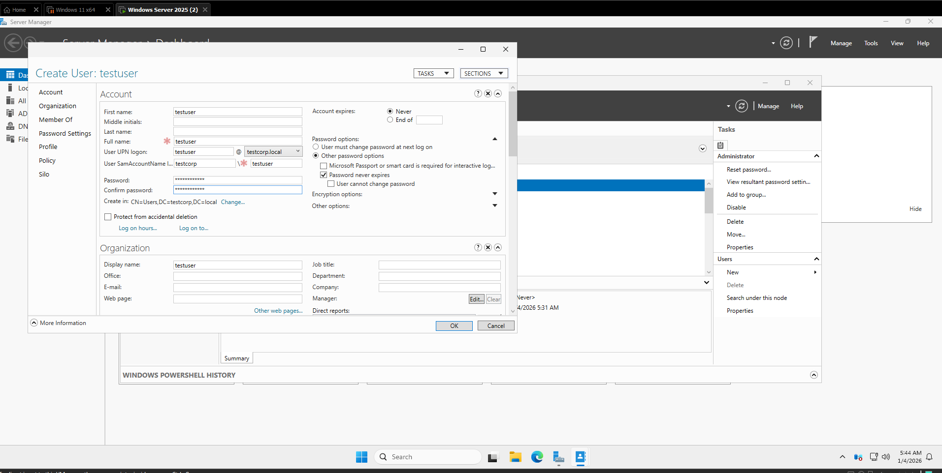
User Creation
A standard domain user account was created using PowerShell.
PowerShell command used:
New-ADUser -Name "Test User" -GivenName "Test" -Surname "User" -SamAccountName "testuser" -UserPrincipalName "testuser@testcorp.local" -AccountPassword (ConvertTo-SecureString "Password" -AsPlainText -Force) -Enabled $true
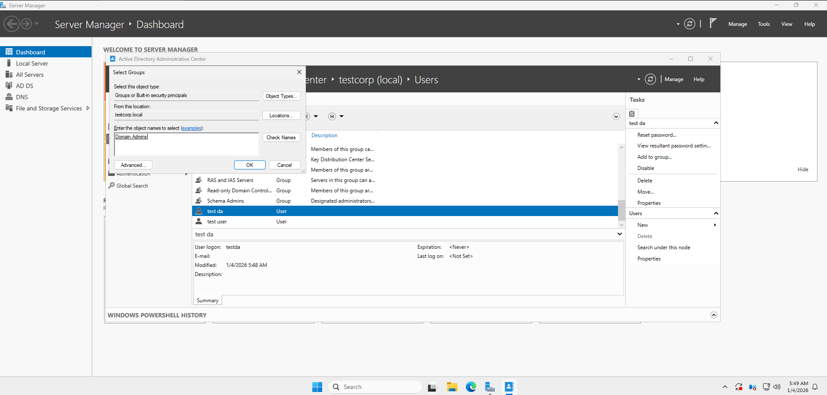
Creating a Domain Administrator Account
A second user account was created to serve as a domain administrator. This account was then added to the Domain Admins group.
PowerShell command used to create the user:
New-ADUser -Name "Test DA" -GivenName "Test" -Surname "DA" -SamAccountName "testda" -UserPrincipalName "testda@testcorp.local" -AccountPassword (ConvertTo-SecureString "Password" -AsPlainText -Force) -Enabled $true
Add-ADGroupMember -Identity "Domain Admins" -Members "testda"

